- Install Apache and run Apache on port number 81

Lanch ec2 instance name as server-1, HA-proxy-server
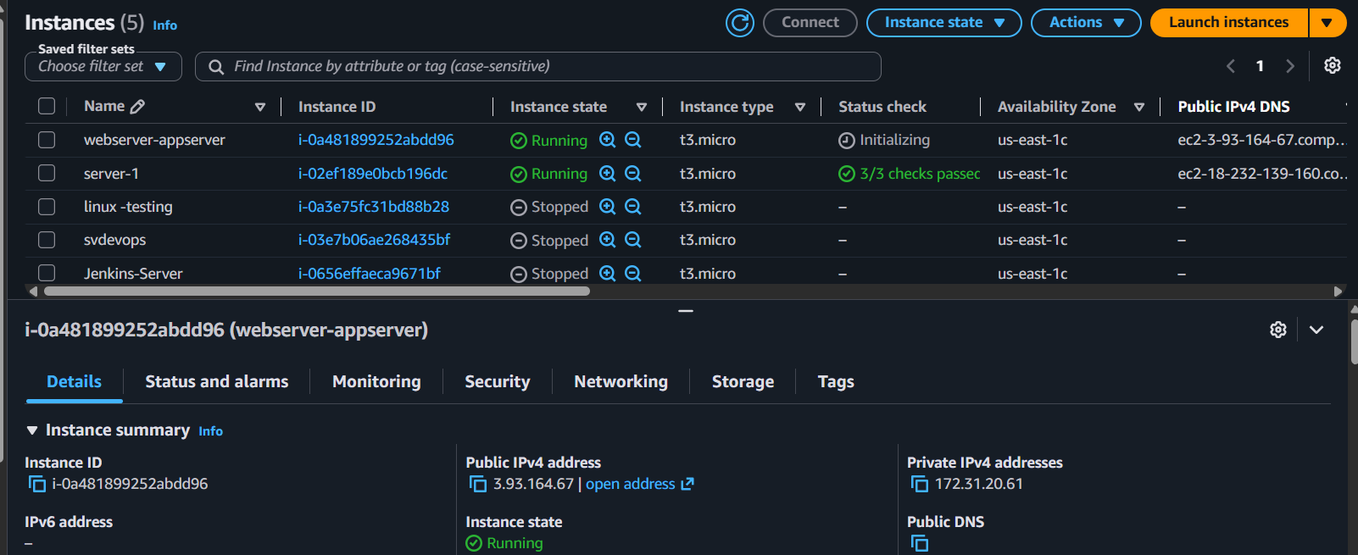
Add inbound role
EC2 → Instances → Select your instance → Security → Security Groups → Inbound rules
SSH | TCP | 22 | 0.0.0.0/0 (for testing) or My IP
Open gitbash terminal
cd ~/Downloads
chmod 400 Jenkins-Server.pem
ssh -i server-2 ec2-user@3.93.164.67

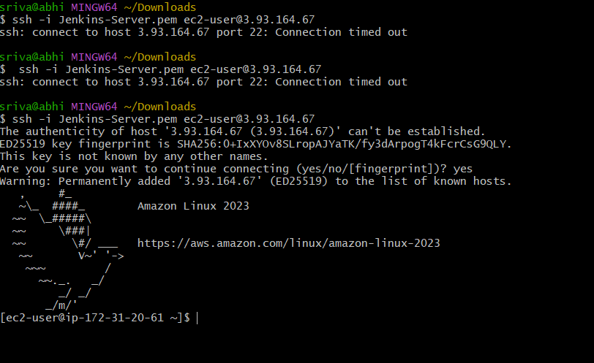
Switch to root usage to avoid permissions
Command :sudo su –

now—install apache (to install apache we need package httpd)
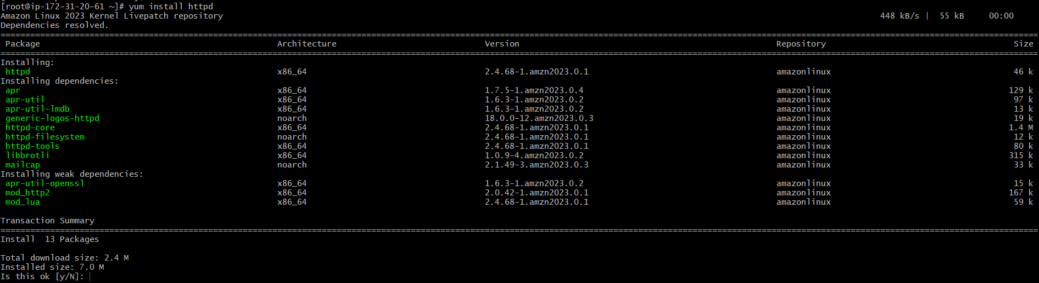
Now apache installed
Now check if the service is running
Method:1
Systemctl status httpd
Inactive
To start service
Systemctl start httpd
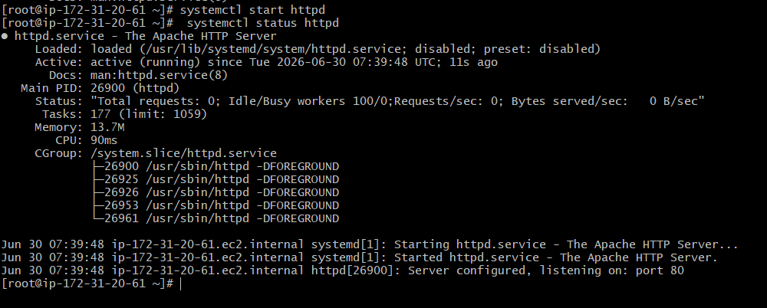
Now running
Apart from systemctl how can we check service is running or not other way to check
With port number we can check

Method:2
Netstat -na | grep 80
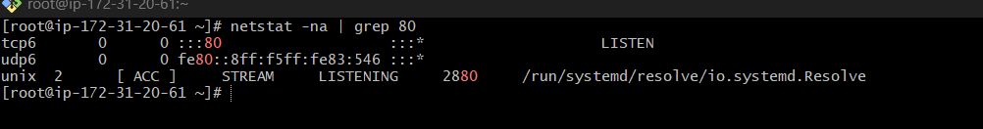
Method:3
lsof -i tcp:80
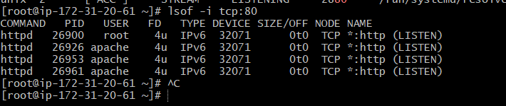

Method:4
Ps -ef | grep httpd
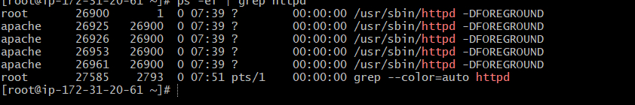
Apache is running
Now I wan to access Apache in browser
Copy : 3.93.164.67 (public ip)
Port no :80
Open browser on you window 3.93.164.67:80
It works !

- Deploy a sample index.html file on Apache.

Create html in neno and write 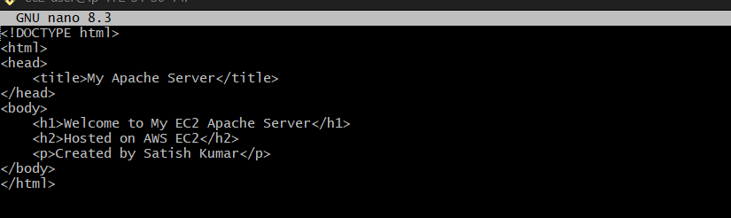
Save and exit
When we refresh the window browser you will updated html

Defult deployment location of : /var /www/html


If you want to change the Apache (httpd) port from 80 to another port (for example, 81), follow these steps on your EC2 instance.
Step 1: Open the Apache configuration file
sudo nano /etc/httpd/conf/httpd.conf
Editot will open press I and edit
Step 2: Find the Listen directive
Search for:
Listen 80
Change it to:
Listen 81

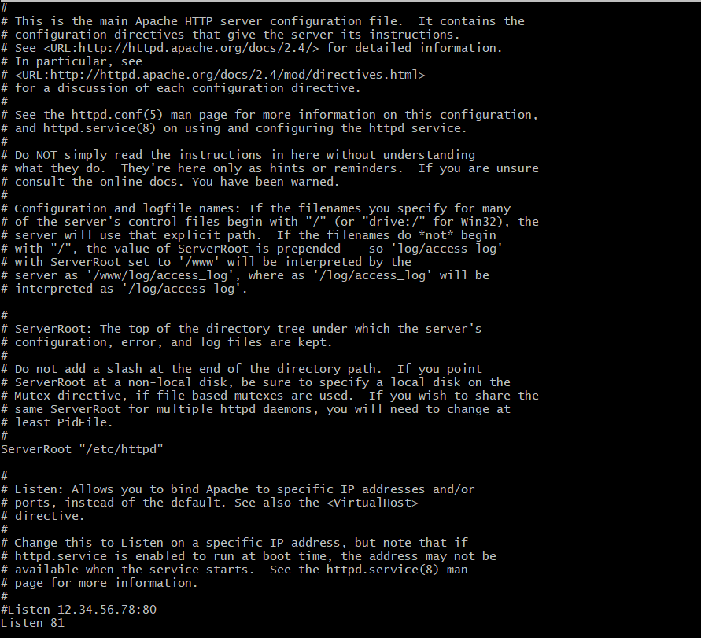
Step 4: Allow port 8080 in the Security Group
Go to:
AWS Console → EC2 → Security Groups → Inbound rules
Add a rule:
Type | Protocol | Port | Source
Custom TCP | TCP | 81 | 0.0.0.0/0
Step 5: Restart Apache
sudo systemctl restart httpd
now edit 81 port number in window browser and refresh


Log files:
Find log:
find / -name acces_log
Location of log files
./var/log/httpd/access_log
/var/log/httpd/error_log

3.Install nginx and run nginx on port number 82

2. install nginx in EC2
Command : sudo yum install nginx
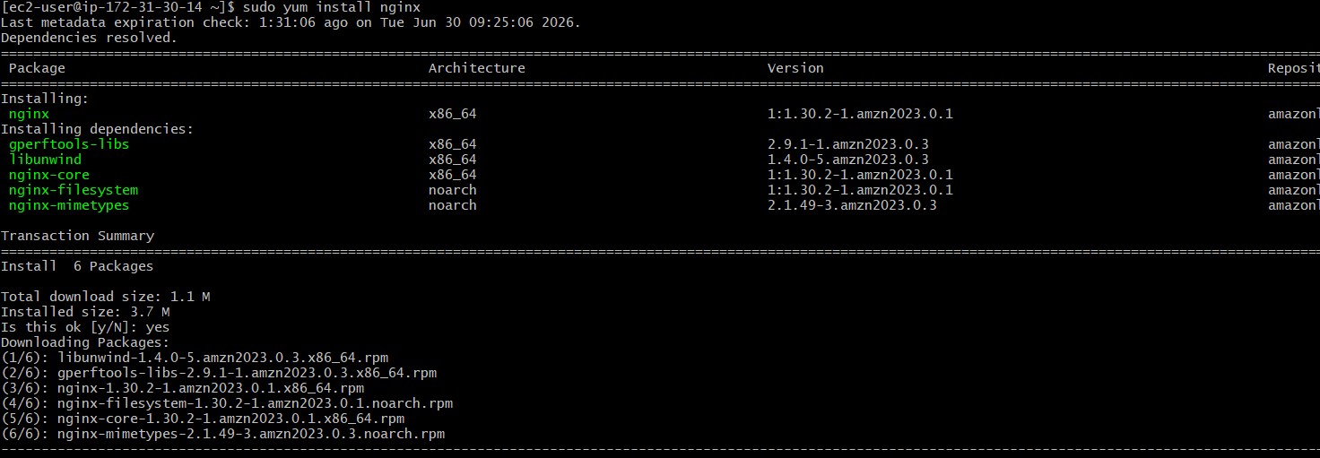
Systemctl status nginx
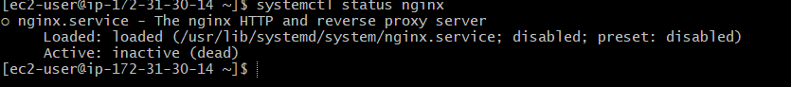
Systemctl start nginx
Systemctl status nginx

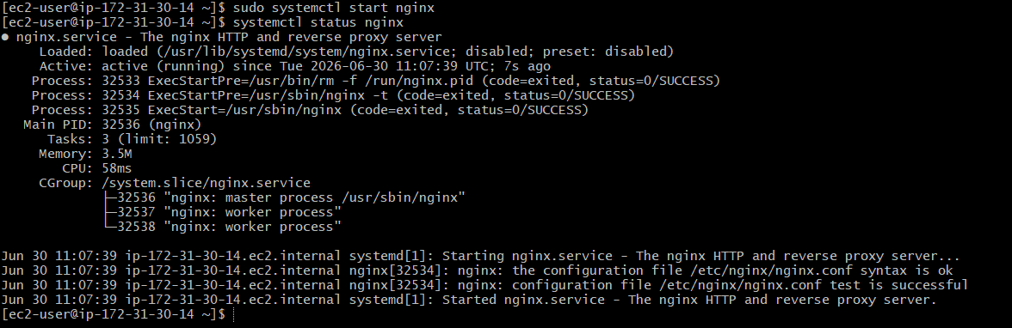
Copy and paste pubip address with port no80 in browser and see
204.236.245.251:80
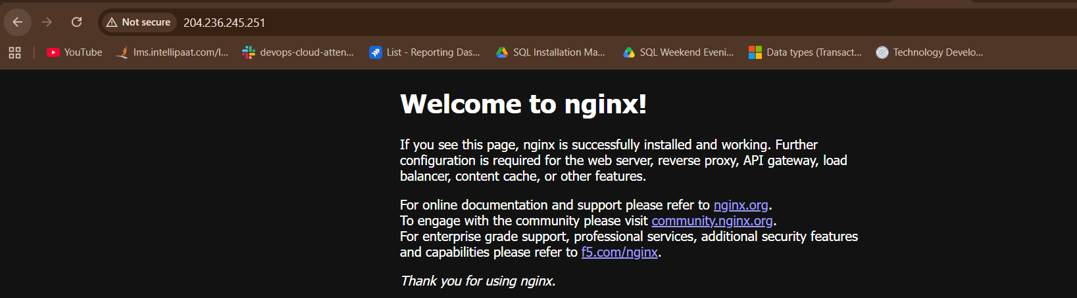

Deploy a sample index.html file on nginx.

Location: cd /usr/share/nginx/html/

Cat index.html
Deploy own page
Vi index.html
Editor will open
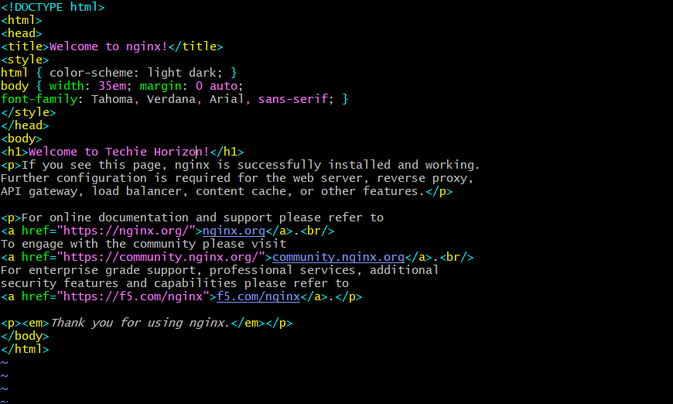
Refresh browser
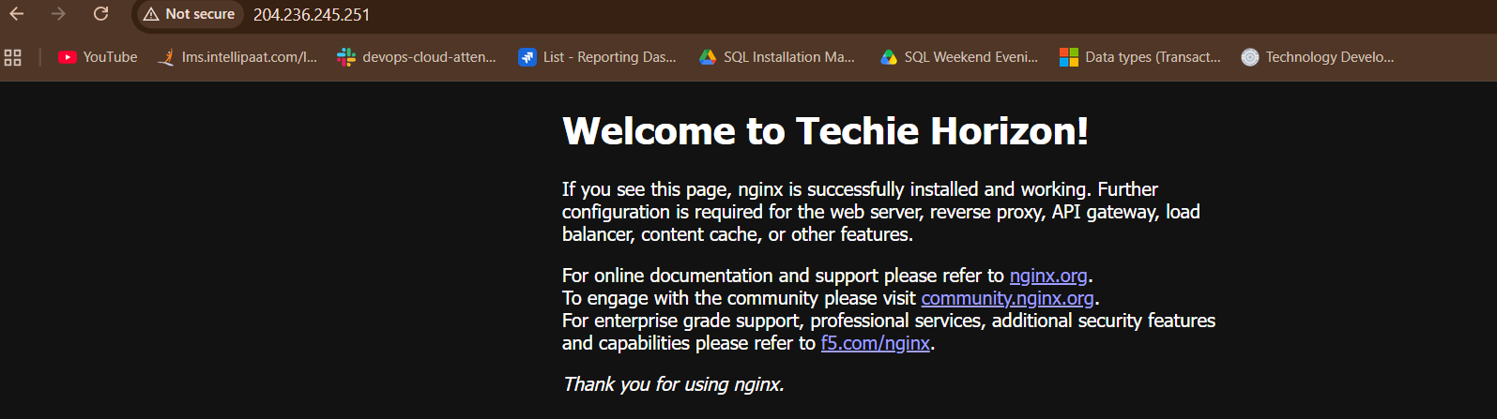

Deploy a sample index.html file on nginx.
Check nginx port number
cat /etc//nginx//nginx.conf
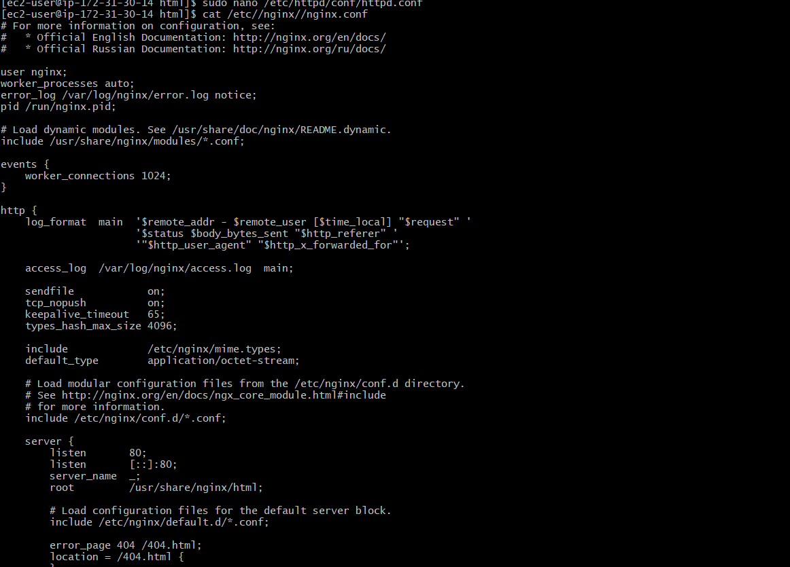
To change nginx port number from 80 to 82
sudo vi /etc/nginx/nginx.conf
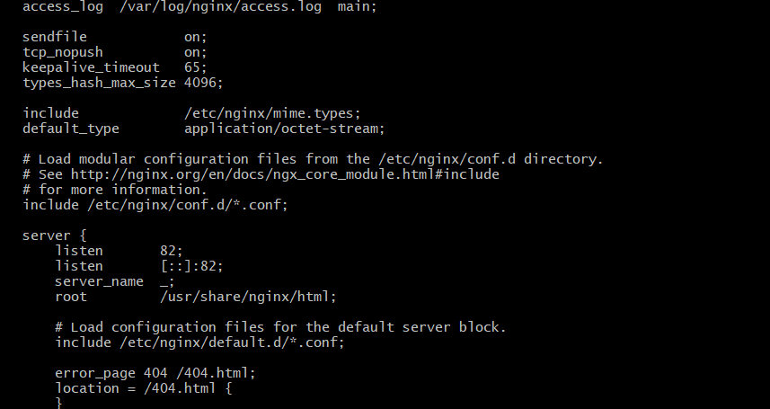
Save and exit
Restart Nginx
sudo systemctl restart nginx
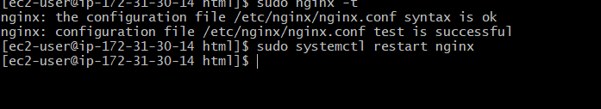
Verify Nginx is listening on port 82
sudo ss -tulnp | grep 82

AWS Console → EC2 → Security Groups → Inbound rules
After that we need to add inbound role in EC2 port 82

Install Apache tomcat on port number 8082
Step 1: Install Java
sudo dnf install java-17-amazon-corretto -y
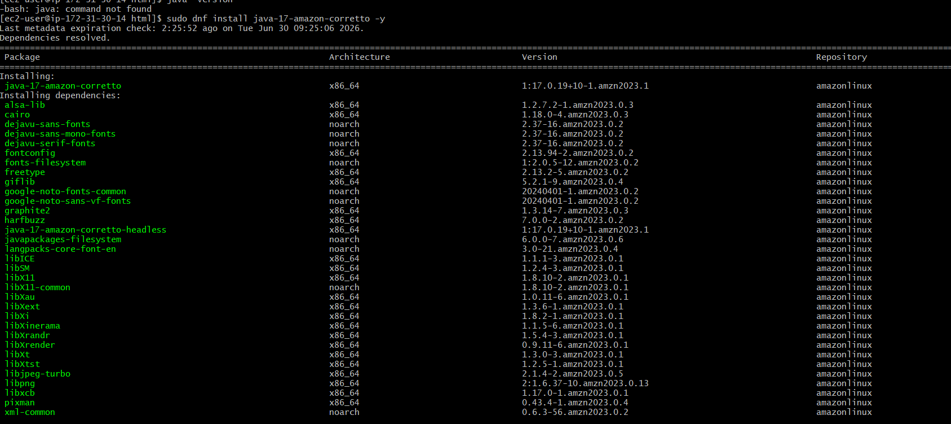
Verify:
java -version
Step 2: Create a Tomcat user
sudo useradd -r -m -U -d /opt/tomcat -s /bin/false tomcat
Step 3: Download Tomcat
cd /tmp
download
wget https://archive.apache.org/dist/tomcat/tomcat-10/v10.1.43/bin/apache-tomcat-10.1.43.tar.gz

verify
ls -lh apache-tomcat-*.tar.gz
error
cat /etc/os-release
location : cd /opt/
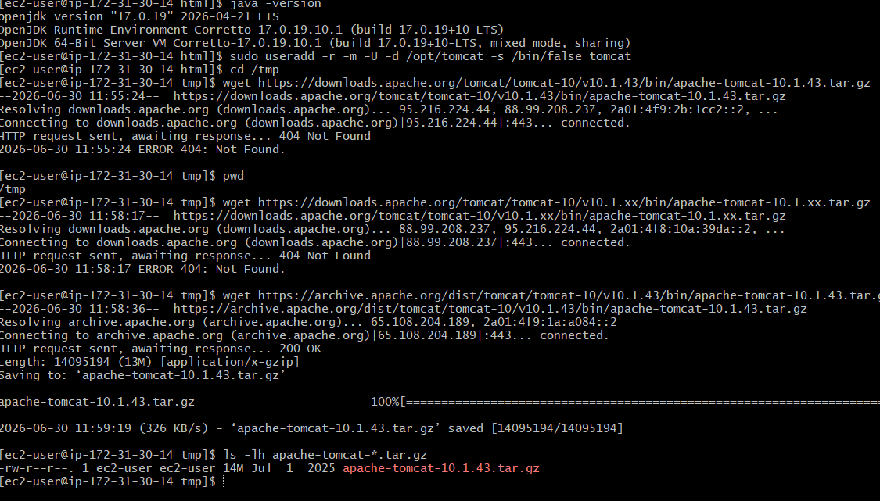

Extract
sudo tar -xzf apache-tomcat-10.1.43.tar.gz -C /opt/tomcat --strip-components=1
Verify
sudo ls -l /opt/tomcat

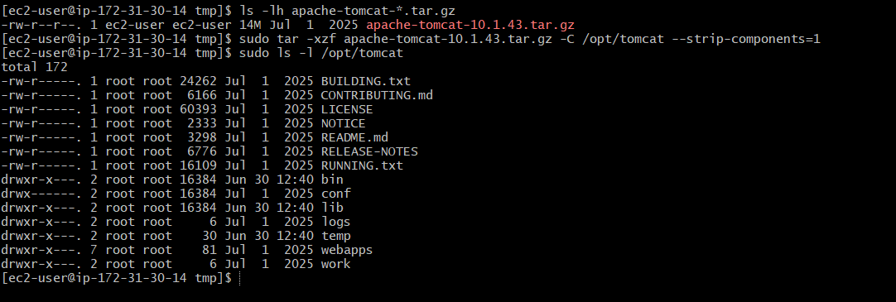
Status running
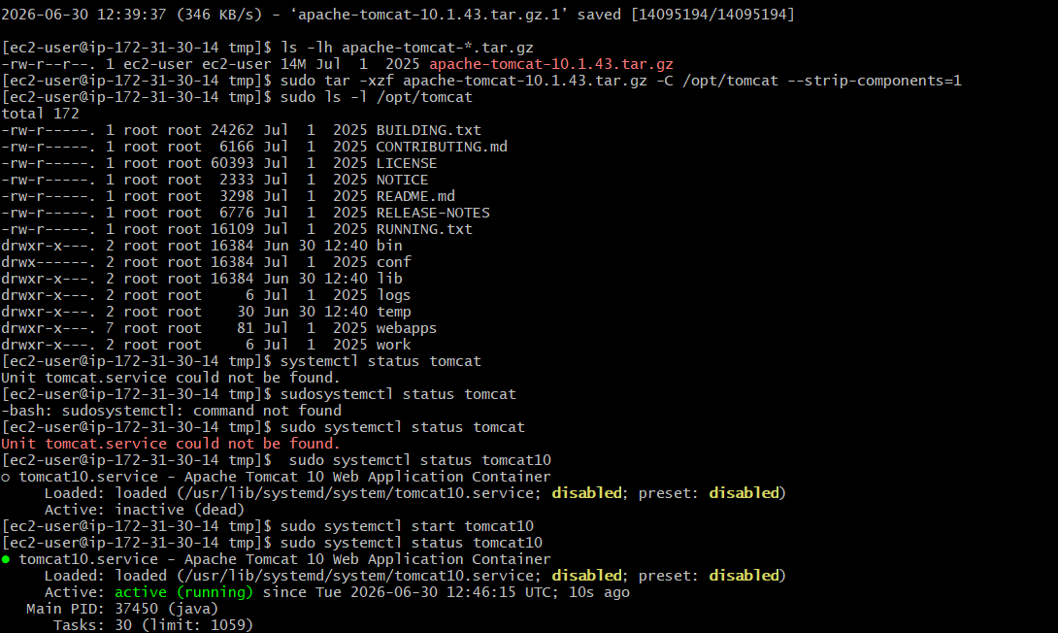
Check port no
Command : netstat -na | grep 8080
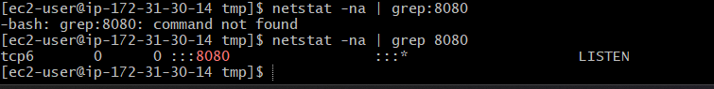
Defult file name of tomcat log is CATLINA

Now we deploye tomact10 on port number 8080
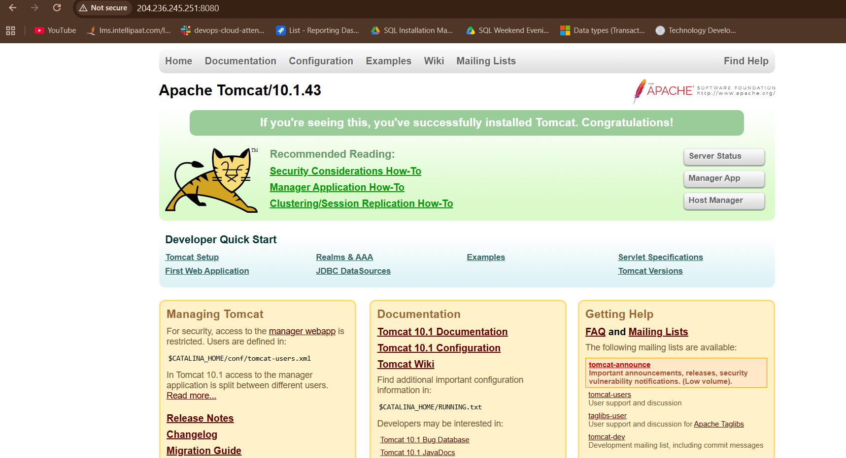

Step 1: Change Tomcat port from 8080 to 8082
Now my tomcate already running on port 8080
I need to change to 8082
Check port noumber
Command: netstat -na | grep 8080
Command : ps -ef | grep tomcat10

Verify if Apache Tomcat is running on a Linux system and find its Process ID (PID
Command: ps -ef | grep tomcat

Now we have path copy the path and
Open the Tomcat configuration file
Command : sudo nano /opt/tomcat/conf/server.xml
server.xml is Tomcat's main configuration file
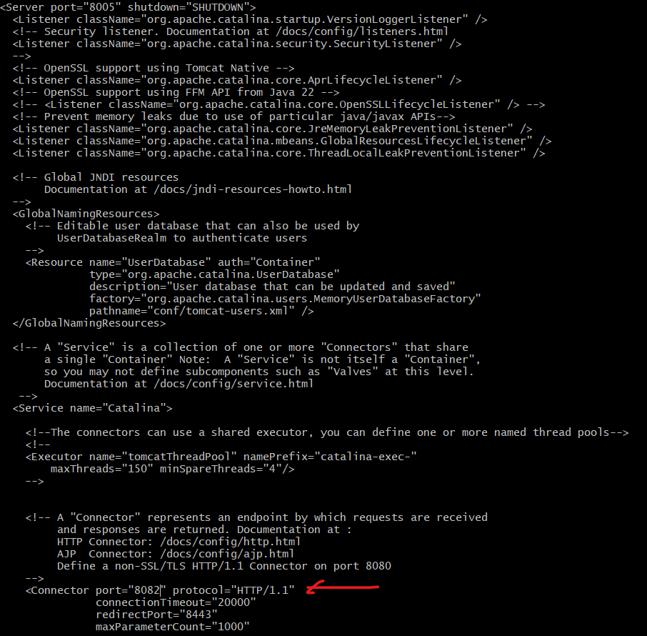

Restart Tomcat
Go to the Tomcat bin directory:
cd /opt/tomcat/bin
sudo ./shutdown.sh
sudo ./startup.sh
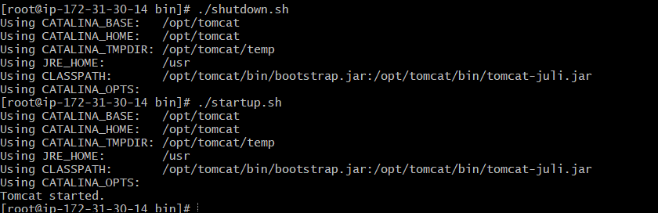
Now verify that port 8082 is active
We can see port no changed from 8080 to 8082

Deploy a sample app on webapps

Method 1: Deploy the Sample ROOT Application (Recommended)
Step 1: Go to the Tomcat webapps directory
cd /opt/tomcat/webapp
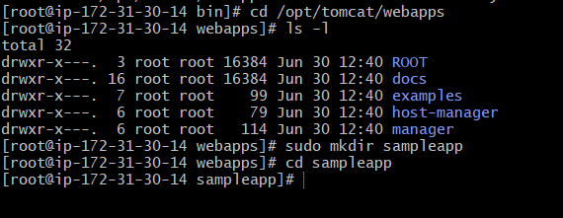
webapps is the default deployment directory in Apache Tomcat.
Step 2: Create a Sample Application
Create a new application directory:
sudo mkdir sampleapp
change directory
cd sampleapp


Create file:
sudo nano index.jsp
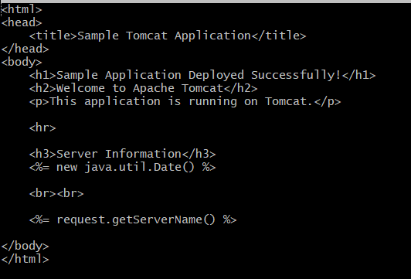
Step 3: Set Ownership
sudo chown -R tomcat:tomcat /opt/tomcat/webapps/sampleapp
Step 4: Restart Tomcat
cd /opt/tomcat/bin
./shutdown.sh
./startup.sh
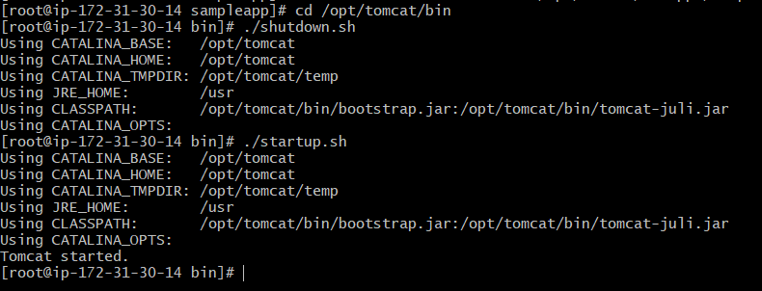
Step 5: Access the Application
Open your browser:
http://<EC2-Public-IP>:8082/sampleapp
error


Check if Tomcat is listening on port 8082
sudo ss -tulnp | grep 8082
add inbound role 8082 in ec2
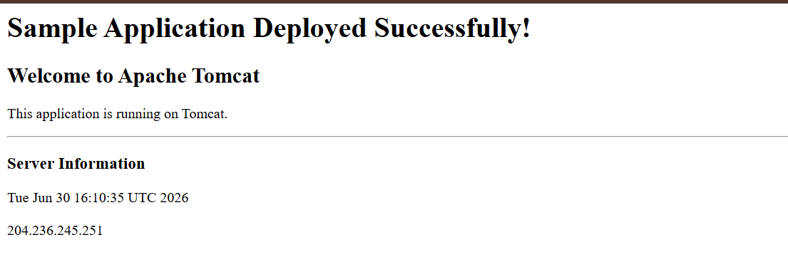Create a tomcat. Service file for tomcat.

Step 1: Create the service file
sudo nano /etc/systemd/system/tomcat.service
/etc/systemd/system/ is the directory for custom service files created by administrators.
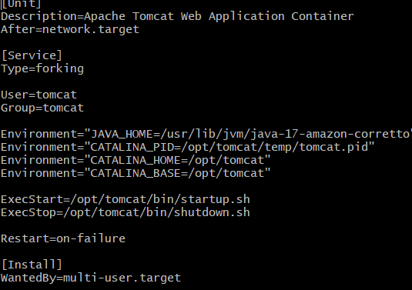

Step 4: Reload systemd
sudo systemctl daemon-reload
Step 6: Start the service
sudo systemctl start tomcat
sudo systemctl status tomcat
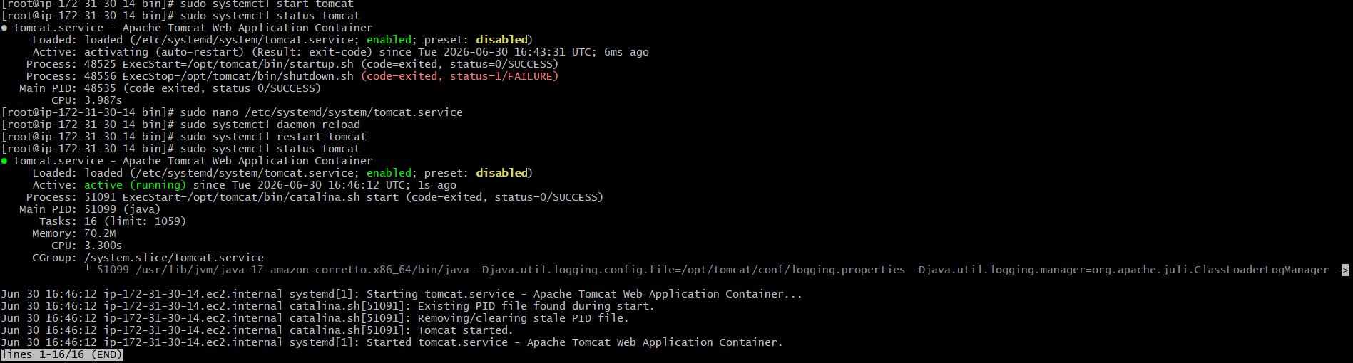
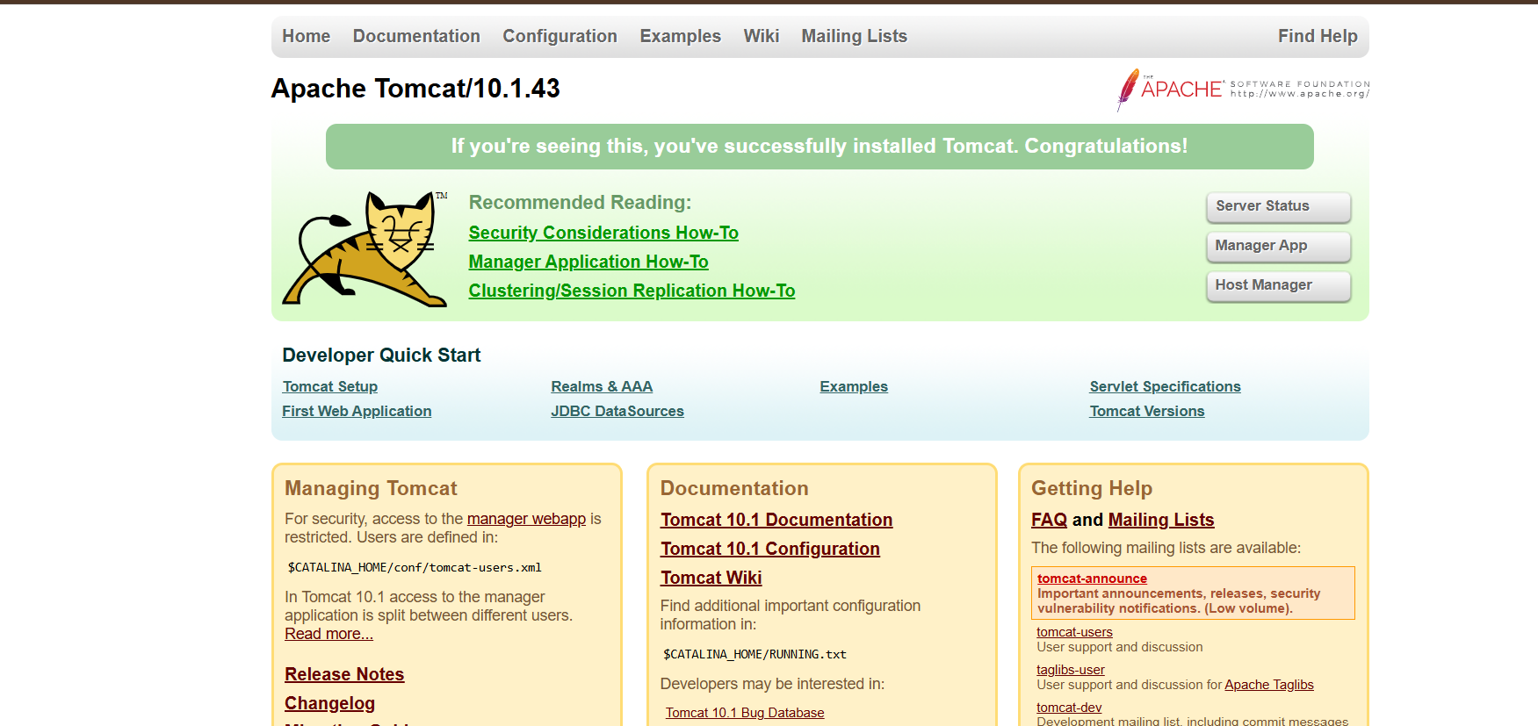

Configure HA Proxy server
connect ec2
Command : ssh -I server-2.pem ec2-user@ 44.215.107.76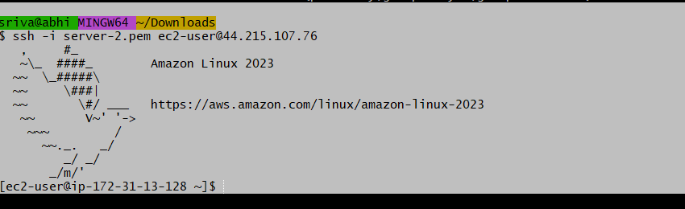

Sudo -i
yum update -y

yum install httpd -y
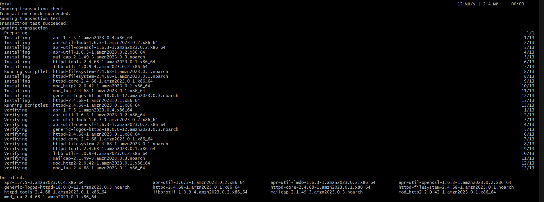
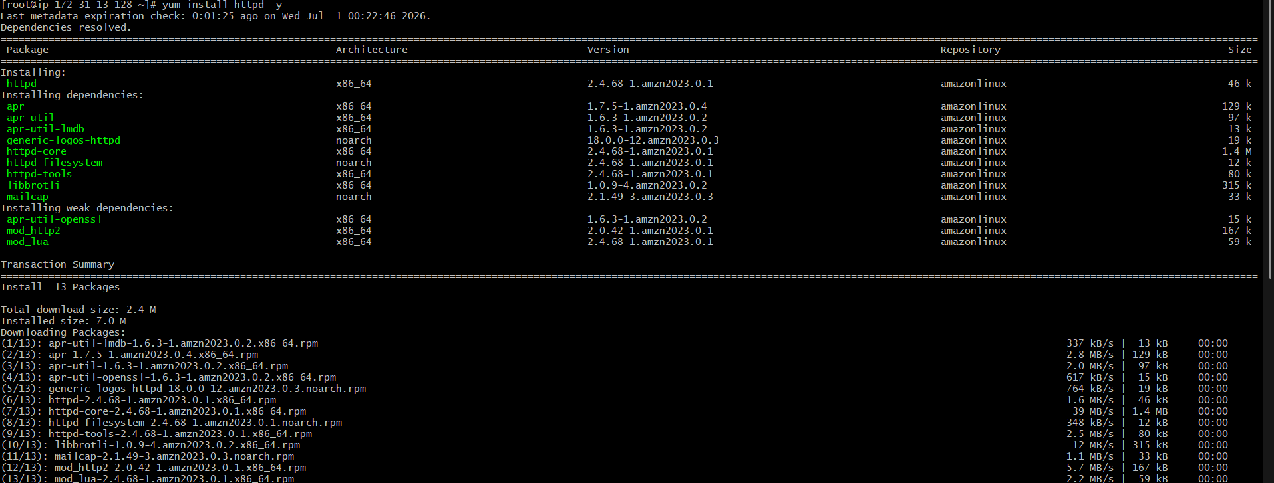

- Vi /etc/hosts
- Add HA-Proxy-Server Pubic IP Address
- 44.203.19.4 haproxy-server
- Proxy name : haproxy-server

ping haproxy-server -c 4
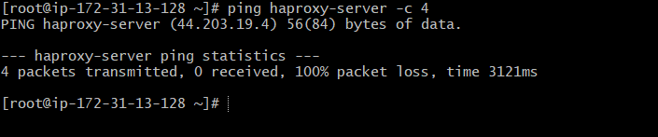
- systemctl start httpd
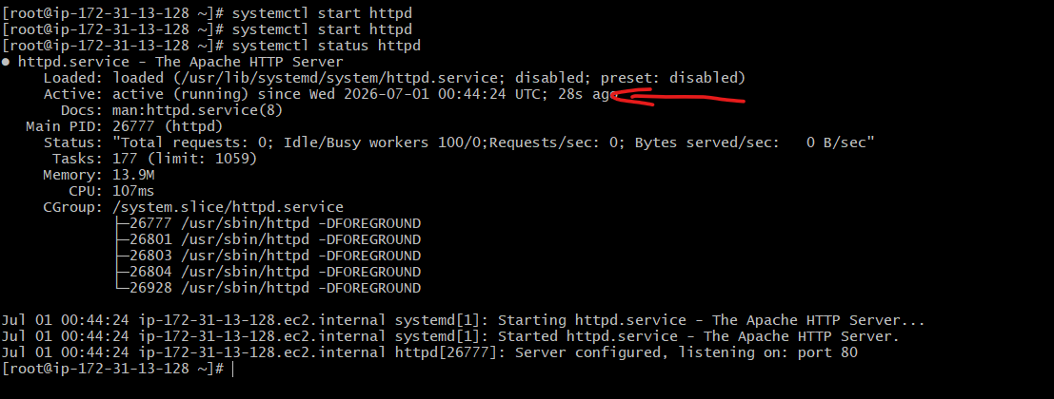
- systemctl status httpd
- Open browser in window and copy HAservcer-1 pub ip :80 paste

It works!

HA Server-2 steps
Access HAserver-2
Run command : ssh -i server-2.pem ec2-user@ 100.52.224.64
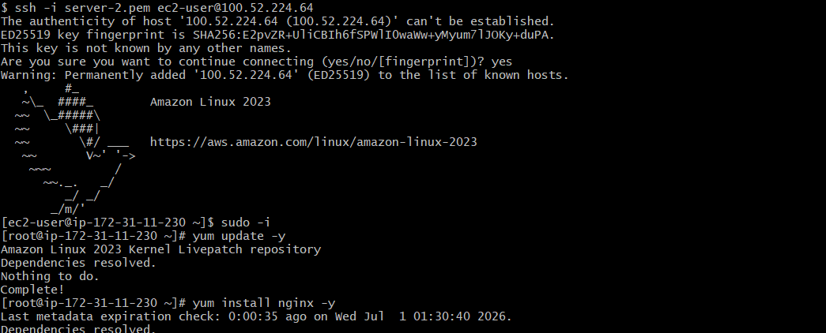

Sudo -i
Yum update -y

Install nginx
yum install nginx -y

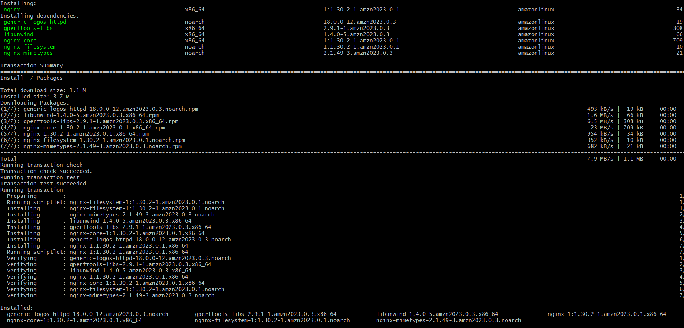
- vi /etc/hosts
- Add HA-Proxy-Server Pubic IP Address


Run below command on Server-2
ping haproxy-server -c 4
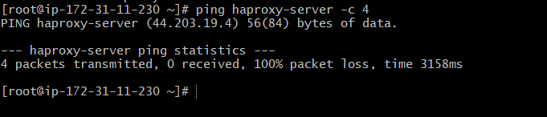

- systemctl start nginx
- systemctl status nginx


HA-Proxy-Server Steps:
Run following command to Access HA-Proy-Server
- ssh -i your-key.pem ec2-user@Pubipaddress of HA-Proxy-Server instance
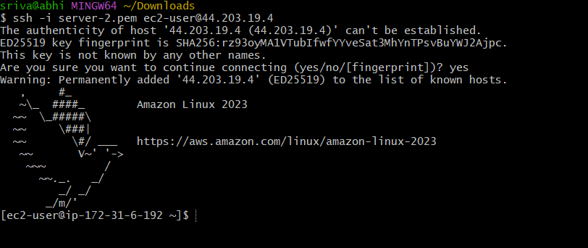

Sudo -i
Yum update -y


Install haproxy

- Command : yum install haproxy -y
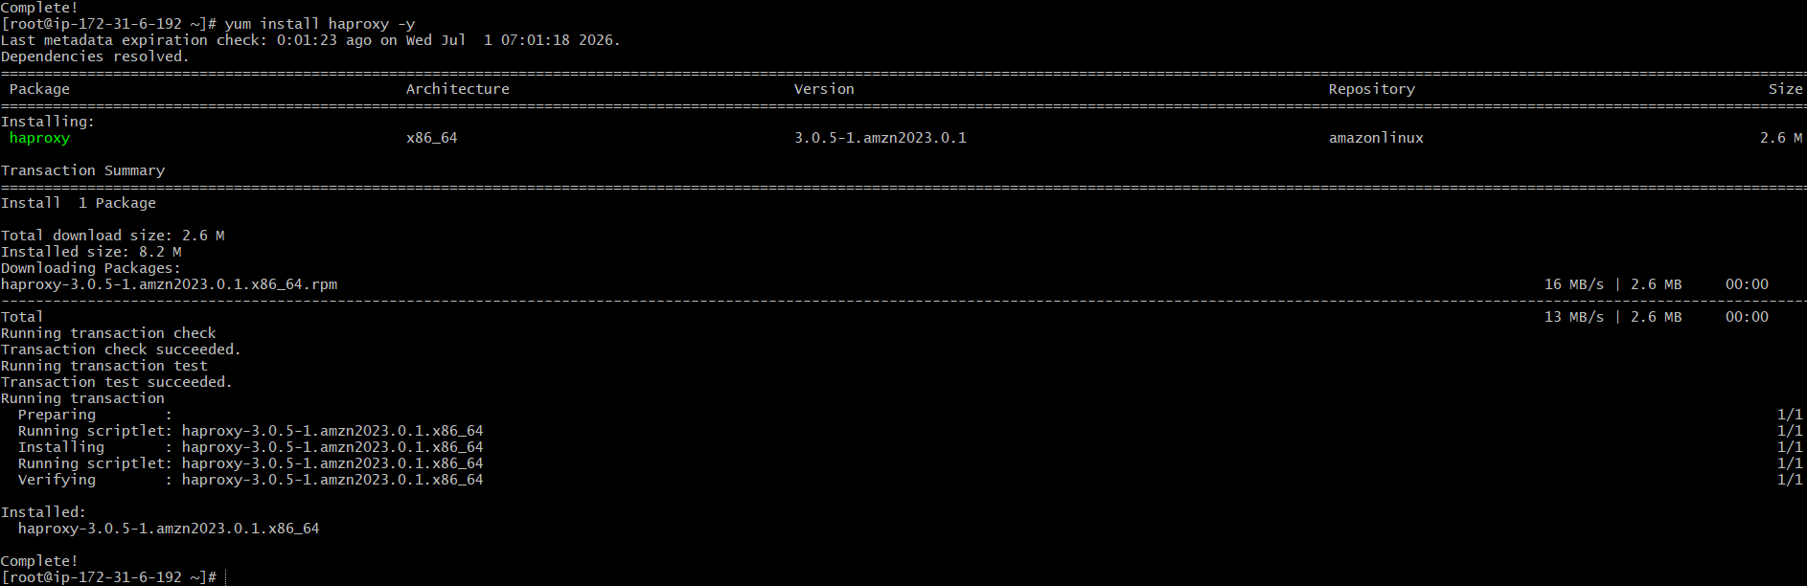

- vi /etc/hosts
- Add Server-1, Server-2 Public IP’s
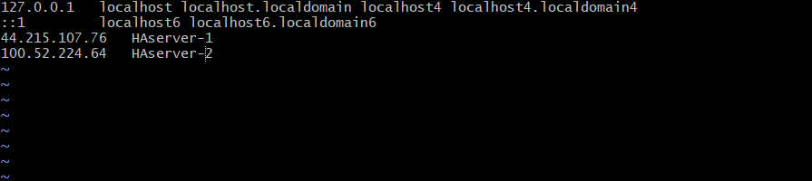

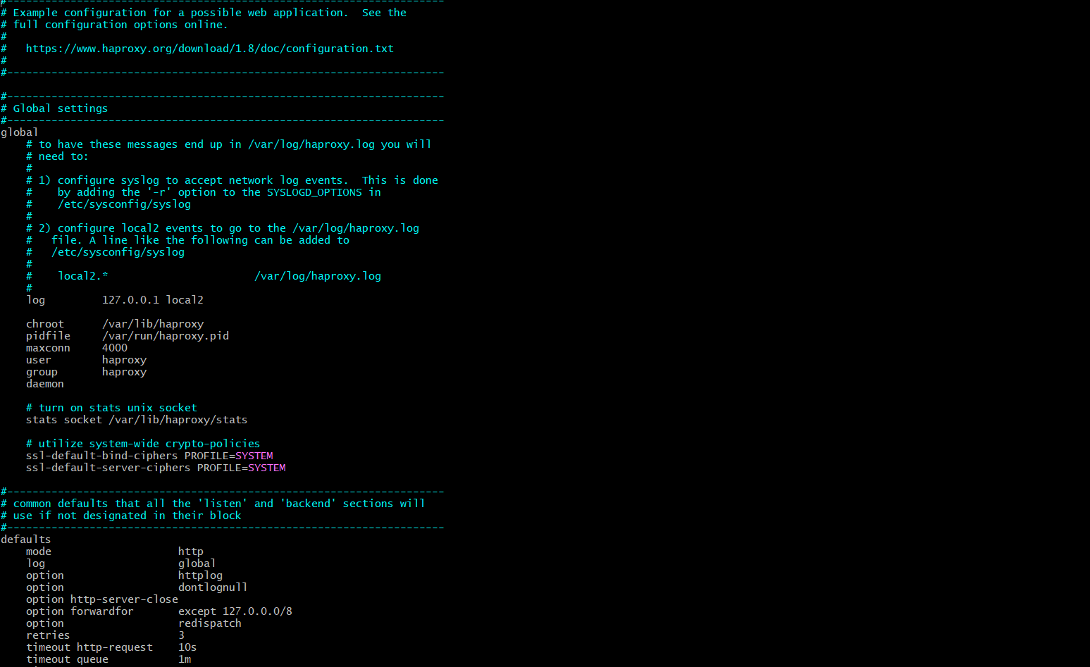

- vi /etc/haproxy/haproxy.cfg
- Add Server-1, Server-2 public IP’s

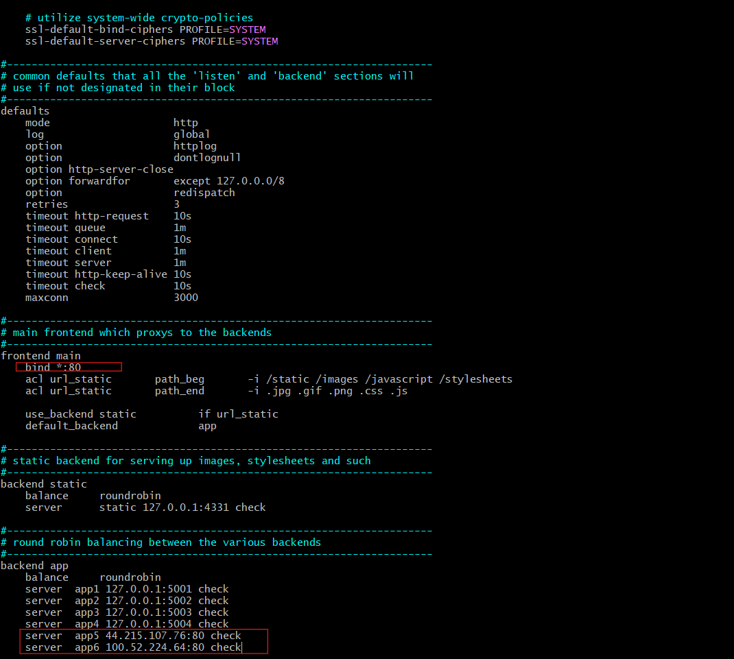
- systemctl enable haproxy
- systemctl start haproxy
- systemctl status haproxy

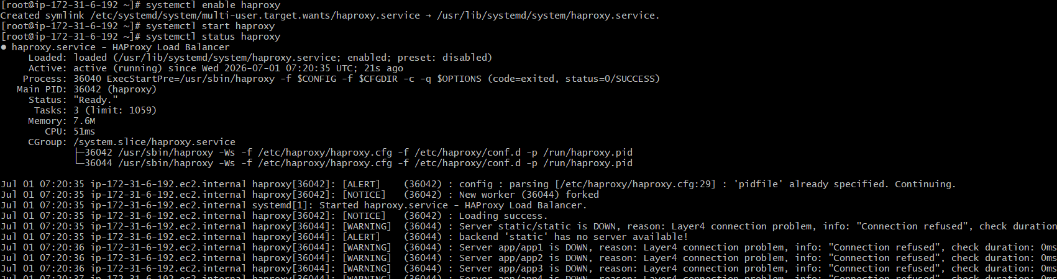
now browse with HA-Proxy-Server PublicIP:80 it will distribute load to Server-1, Server-2
working with haproxy

